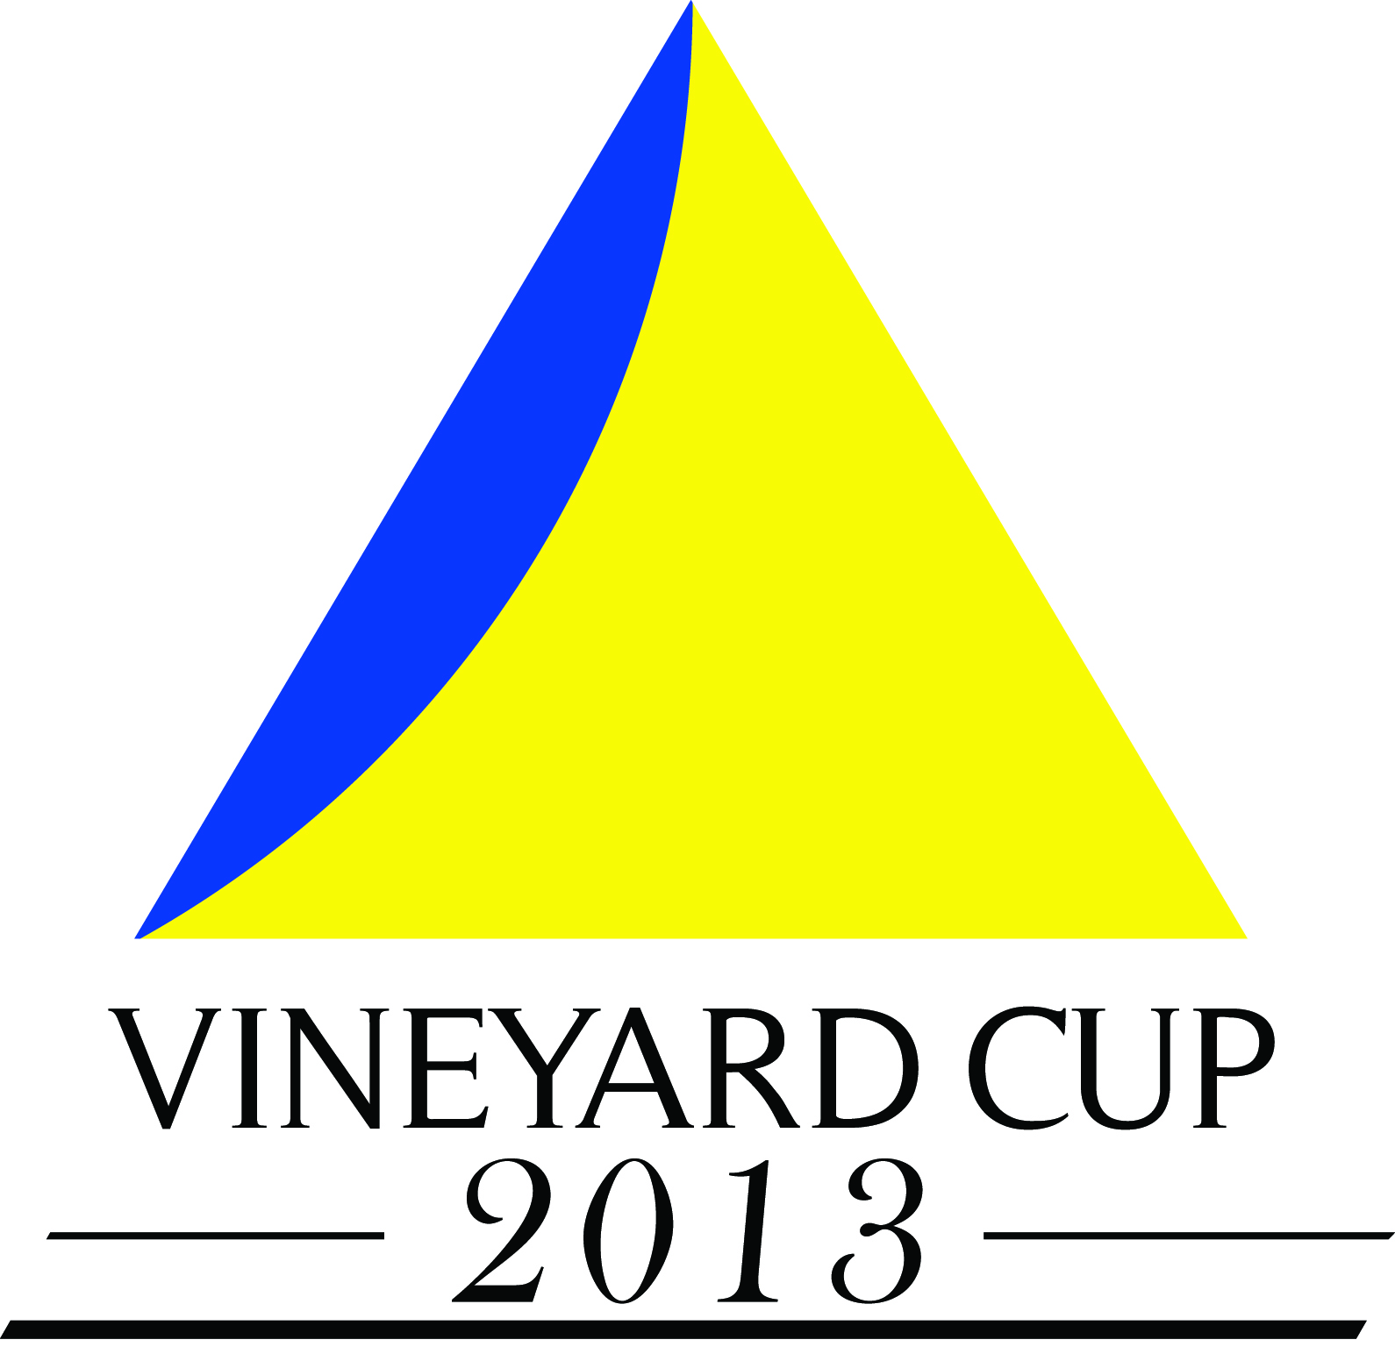
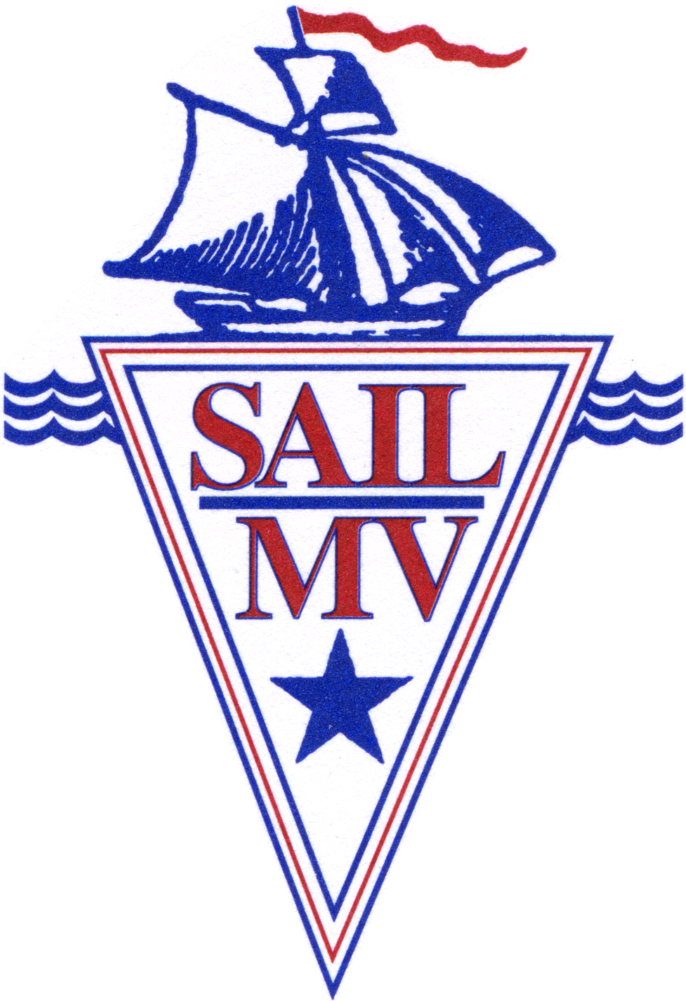
The Vineyard Cup Regatta will be held on the waters of Nantucket Sound and Vineyard Sound off of the Island of Martha’s Vineyard on Friday, Saturday and Sunday, July 12th, 13th and 14th, 2013. Sail Martha’s Vineyard (“SMV”) is the Organizing Authority www.sailmv.com and invites vessels 18 feet in length and greater to come and enjoy a fun and affordable event. All proceeds of the event help to support the year round maritime programs of Sail Martha’s Vineyard.

NOTICE OF RACE

- RULES
  - The regatta will be governed by the rules as defined in The Racing Rules of Sailing 2013-2016 (“RRS”), the prescriptions of US SAILING, any modifications or stated exceptions thereto, Class Rules for any One-Design Class competing and the Sailing Instructions.

- OTHER RULES and REQUIREMENTS
  - All boats must be sailed by a minimum of two sailors.
  - There are no weight limitations

- ADVERTISING
  - The Cup will be sailed in accordance with ISAF Regulation 20.
  - Vessels may be asked to display a sponsors’ flag provided by the Organizing Authority as permitted by ISAF regulation 20.4.1

- ELIGIBILITY
  - The regatta is open to boats at least 18 feet LOA who either (i) carry a PHRF rating or (ii) fall within the categories of Classic boats, Catboats or Small boats. If entries in any Division warrant, a Division will be divided into Classes to be established at the sole discretion of the Organizing Authority and designated based on one-design class, rating and/or hull material or configuration or any combination thereof.

Eligible boats may enter by completing the online registration form and paying the entry fee online. All boats except the Classic, Catboat and Small Boat Divisions must submit a 2013 rating certificate. Entries and payment may also be sent to Vineyard Cup Entries, c/o Sail Martha’s Vineyard, P.O. Box 1998, Vineyard Haven, Massachusetts 02568.
  - Entries must be received by 1800 hrs July 5, 2013

A 2013 PHRF certificate can be applied for through the Sail Martha’s Vineyard Fleet. (Application available at www.phrfne.org.) Fill out and send to Sail MV with $25 check made out to Sail MV.

- CLASSIFICATION
  - The Classic Division is for boats greater than 24 feet in length and are of wood or steel construction and not rated under PHRF
  - The Small Boat Division is for boats less than 24 feet in length or whose PHRF rating is greater than 250 seconds per mile.
  - The PHRF Non-Spinnaker Division: A 2013 PHRF-NE Certificate MUST be presented. THERE WILL BE NO EXCEPTIONS.
  - The PHRF Spinnaker Division: A 2013 PHRF-NE Certificate MUST be presented. THERE WILL BE NO EXCEPTIONS.
  - The IRC Division: A 2013 IRC Certificate MUST be presented. THERE WILL BE NO EXCEPTIONS.

- FEES
  - The entry fee in the Classic Division is $150.00
    - The entry fee for Classic boats designed before 1945 will be $100.00.
  - The entry fee for PHRF, PHRF Spinnaker and IRC is $150.00
    - The entry fee for boats with an LOA of less than thirty feet will be $100.00.
  - The entry fee for boats in the Catboat and Small Boat Divisions is $75.00.
  - Sail Martha’s Vineyard may in its sole discretion accept any late entry at any time. A $50.00 late entry fee will apply.
  - Bracelets entitling the wearer access to the Event Tent with food and drink included will cost $80 for all three nights or $30 a night for those over 21 years of age.
    - Those under 21 years of age may purchase bracelets for $60 for the weekend or $25 a night.
    - Children under the age of 12 years of age are FREE.

- PRELIMINARY RACING SCHEDULE

  - Friday, Saturday and Sunday, July 12, 13 and 14, 2013

The PHRF Spinnaker, PHRF Non-Spinnaker and IRC Divisions

FRIDAY, JULY 12, 2013
First Warning Signal 1300 hrs Division/Class Flag
Preparatory Signal 1305 hrs Code Flag “P”
Start 1310 hrs Div/Class Flag Down

SATURDAY, JULY 13, 2013
First Warning Signal 1015 hrs Division/Class Flag
Preparatory Signal 1020 hrs Code Flag “P”
Start 1025 hrs Div/Class Flag Down

SUNDAY, JULY 14, 2013
Pursuit Race First Boat Warning Signal 1030 hrs Yellow Flag
Preparatory Signal 1035 hrs Blue Flag
Pursuit Starting Sequence Begins 1040 hrs Red Flag

The Classic Division

SATURDAY, JULY 13, 2013
First Warning Signal 1000 hrs Division/Class Flag
Preparatory Signal 1005 hrs Code Flag “P”
Start 1010 hrs Div/ Class Flag Down

SUNDAY, JULY 14, 2013
Pursuit Race First Boat Warning Signal 1030 hrs Yellow Flag
Preparatory Signal 1035 hrs Blue Flag
Pursuit Starting Sequence Begins 1040 hrs Red Flag

The Small Boat Division

SATURDAY, JULY 13, 2013
First Warning Signal 1200 hrs Division/Class Flag
Preparatory Signal 1205 hrs Code Flag “P”
Start 1210 hrs Div/ Class Flag Down

- SAILING INSTRUCTIONS
  - Sailing Instructions for the PHRF, IRC, Classic and Catboat Divisions will be posted on the Vineyard Cup website, www.vineyardcup.com and be available at Race Headquarters beginning at 0900 hrs. July 11, 2013 and at the Competitors Meeting.

- RACE HEADQUARTERS
  - Race Headquarters will be located at the Sail Martha’s Vineyard’s offices which are located at 110 Main Street in Vineyard Haven, up the hill and across Main Street from the Town Dock at Owen Park.

- RACE COURSES
  - The course to be sailed will be displayed on the Race Committee Boat Course Board (starboard side) and transmitted over VHF Channel 73 approximately ten minutes before the starting sequence.
  - All Divisions and All Classes (see Appendix for graphic representations):

COURSE #1 L’HOMMEDIEU SHOAL COURSE (approximately 10.9 nm)
Start to N”4” (leave to port) to C”25” (leave to port) to R”26” (leave to starboard) to C”15” at the western end of L’Hommedieu Shoal (leave to starboard) to RG N at the west end of Hedge Fence (leave to starboard) to Finish.

COURSE #2 RACE TO THE ROCK…AND BACK (approximately 29.1 nm)
Start to N “4” (leave to port) to C”25” (leave to port) to GR Lone Rock at the north entrance to Quicks Hole (leave to starboard) to C”25” (leave to starboard) to N “4” (leave to starboard) to Finish.
NOTE: Skippers may approach and return from Lone Rock by any course they choose. Passage through Wood’s, Robinson’s or Quick’s Holes in either direction is permitted.

COURSE #3 CAPE POGE COURSE (approximately 16.9 nm)
Start to C”23A” (leave to starboard) to GR east of the Oak Bluffs ferry pier (leave to starboard) to C”1” Lone Rock off Oak Bluffs (leave to starboard) to Skiff #1 approximate position of 41° 25’ 35” N by 70° 32’ 30” W (leave to port) to R”2” (leave to starboard) to G”21A” approximately 2.1 nm northeast of Cape Poge (leave to port) to RG N at the west end of Hedge Fence (leave to port) to Finish.

COURSE # 4 EDGARTOWN COURSE (approximately 11.1 nm)
Start to C”23A” (leave to starboard) to GR east of the Oak Bluffs ferry pier (leave to starboard) to C”1” (leave to starboard) to Skiff #1 approximate position of 41° 25’ 35” N by 70° 32’ 30” W (leave to port) to R”2” off of Edgartown (leave to port) to Finish.

COURSE #5 HEDGE FENCE COURSE (approximately 10.5 nm)
Start to C “23” (leave to starboard) to R “22” (leave to starboard) to GR Bell (leave to starboard) to G “23” (leave to port) to Finish.

Course # 6 LUCAS SHOAL COURSE (approximately 21.3 nm)
Start to R “2” (leave to port) to C “25” (leave to port) to G “27 (leave to port) to GR C “LS” at Lucas Shoal (leave to port) to C”25” (leave to starboard) to R “2” (leave to starboard) to Finish.

NOTES:
- ALL BOATS SHOULD TREAT N”4” AND C”23A” AS A GATE AND SHALL PASS BETWEEN THEM OUTBOUND FROM THE START LINE AND INBOUND TO THE FINISH LINE. THERE ARE NO EXCEPTIONS TO THIS REQUIREMENT.
- The start and finish lines will be positioned approximately ¼ nm (at a bearing of 65° M) from Fl G “7” at the end of the Eastville jetty.
- Skiff #1 is used as a mark in Courses #3 and #4 will be 12’ white Flatiron Skiffs and will fly a 4’ x 4’ orange flag from its mast.

- SCORING and ALTERNATIVE PENALTIES
  - Each Division and Class will be scored separately for the purpose of Awards
  - Time-over-distance ratings developed by the Race Committee to the best of its ability and in the recreational spirit of the Classic and Small Boat Divisions will be assigned to each boat entered in those Divisions.
  - PHRF NE ratings will be used for the PHRF Spinnaker and Non-Spinnaker Divisions. A valid 2013 certificate for each boat entered must be on file with the Race Committee.
  - No score will be excluded in any Division. This changes Rule A2
  - RRS 44.3 (c), Scoring Penalty shall be 25% of the number of boats in a Class

- PRIZES
  - Trophies will be awarded as follows:
    - Two Vineyard Cup awards:
      - To the PHRF boat with the best cumulative corrected finishing places based on corrected times for Friday and Saturday’s races and on actual finishing place in her class for Sunday’s pursuit race
      - To the Classic boat with the best cumulative finishing places based on corrected times for Saturday’s race and on actual finishing place for Sunday’s pursuit race.
    - In the IRC Division
    - In the Classic Division
    - In the PHRF Non-Spinnaker Division
    - In the PHRF Spinnaker Division
    - In the Small Boat Division
    - By Morris Yachts for the Morris yacht with the best cumulative corrected finishing places

- CLEAN REGATTA
  - The Vineyard Cup Regatta is committed to maintaining and improving the water quality in Vineyard and Nantucket Sounds. As such,
    - The Vineyard Cup is registered in the Sailors for the Sea’s Clean Regattas program. All Vineyard Cup Regatta participants are encouraged to follow the goals and requirements of Clean Regattas. The requirements include:
  - No discharge of treated or untreated sewage or black water in harbor areas or no-discharge zones around Martha’s Vineyard
  - No overboard discharge of trash or littering at shore facilities (e.g., rigging tape, cigarette butts, beer cans).
  - Follow Martha’s Vineyard’s trash and recycling guidelines: Trash must be in clear plastic or biodegradable bags. All paper, glass, metal, and plastic must be recycled and placed in separate containers.
  - Reduce plastic waste by using refillable water bottles.
  - Use green cleaning and maintenance products.
  - Reduce the impact of oil spills from motorized vessels by carrying at least one bilge sponge and fuel spill pad

- SHORESIDE PARTIES
  - There will be harbor-side parties each day under the Race Village tents. Food, Beverage, Music, Daily Awards and Sponsor Handouts. Entrance subject to the purchase of daily or weekend bracelets.
  - On Saturday night at 0800 hours there will be a free and open to the public concert at the Race Village located at the Beach Road Extension. All are welcome.

- LIABILITY
  - The safety of a boat and its crew is the sole and inescapable responsibility of the Skipper/Owner who must ensure that the boat is fully sound, thoroughly seaworthy and crewed by an experienced and physically capable crew. The decision of whether or not to start or continue a race is solely that of the skipper.
  - The Skipper/Owner of each boat participating in the Vineyard Cup Regatta shall be responsible for the behavior of each member of the crew of his/her boat, both while on the water and ashore.
  - Sail Martha’s Vineyard, the participating Sponsors and Industry Partners of the 2013 Vineyard Cup do not accept responsibility for loss of life or injury to participants nor for the loss of nor damage to any vessel in any way from any cause during the Vineyard Cup.
- AMENDMENTS TO THIS NOTICE
  - Sail Martha’s Vineyard reserves the right to amend this notice. Any amendments of this notice will be posted on the Vineyard Cup and Sail Martha’s Vineyard websites and notices sent to all boats registered at that time. All amendments will be posted on the Vineyard Cup website www.vineyardcup.com, and hard copy will be posted on the Official Notice Board at Race Headquarters.

